Description: I want to create a partition table using partition by list method

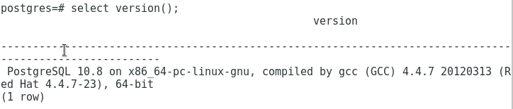
I have used the code given in PARTITION BY LIST
https://www.enterprisedb.com/docs/en/9.4/oracompat/Database_Compatibility_for_Oracle_Developers_Guide.1.314.html

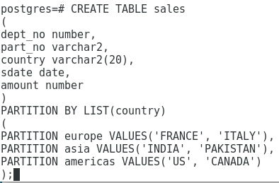
Error:
It is giving me an error
